Staff Report
Meeting Date: September 7, 2021
To: Siskiyou County Board of Supervisors
From: Bernadette Cizin, Assistant Planner
Subject: Intention to Serve Notice of Non-Renewal of Williamson Act Contracts for Certain Properties

Background
In 1965, the California Legislature passed the Land Conservation Act (Williamson Act), which authorizes local governments to enter into contracts with private landowners for the purpose of restricting development to agricultural, open space, and recreational related uses in exchange for reduced property tax assessments.
To offset the loss in property taxes, local governments use to receive subvention funds from the State through the Open Space Subvention Act (OSSA) of 1971. Between 1972 and 2008, the average State subvention payment totaled $23.3 million per year. In 2009, the subvention payments were reduced to $1,000 annually. There have been no subvention payments made to counties since 2009.
Pursuant to the rules and procedures for the Siskiyou County’s Williamson Act program, county Planning staff recently surveyed properties under Williamson Act contract to verify compliance and determine whether landowners are using their property for commercial agricultural operations in order to assure the intent of the program of encouraging commercial agricultural production is being carried out in Siskiyou County. It should be noted that there are approximately 496 individual Williamson Act contracts covering approximately 2,566 separate APNs in Siskiyou County.
On July 1, 2021, Planning staff mailed out a survey request to properties under Williamson Act contract to gather agricultural production information to ensure compliance with the intention of the Williamson Act and County policies. As a result of compliance monitoring, seven contracts covering 26 separate APNs have been identified that do not meet the intention of the Williamson Act and/or our county policies due to either non-response, information provided on the survey response, and/or past/current activities. The seven contracts and associated APNs are listed below and are outlined in Exhibit A-1 to the attached Resolution. The recorded contracts are also included in Exhibit A-3 to the attached Resolution. In addition, a general vicinity map of the seven contracts recommended for issuance of notice of non-renewal is included on page 2 of this staff report.
- Contract # 20032 – total of 69.1 acres, includes: APN 022-230-440
- Contract # 71069B – total of 160 acres, includes: APN 041-150-010
- Contract # 73019 – total of 120 acres, includes: APNs 010-140-230, 010-150-050 and 010-150-180
- Contract # 76023 – total of 769.14 acres, includes: APNs 019-010-080 and 019-021-070
- Contract # 76025 – total of 881 acres, includes: APNs 010-140-200, 010-140-240, 010-140-250, 010-140-420, 010-140-430, 010-150-260, 010-150-270, 010-150-320 and 010-150-330
- Contract # 76033 – total of 985.8 acres, includes: APNs 002-150-040, 002-170-070, 002-170-240, 002-170-250, 002-170-270, 002-330-250, 010-010-550, 010-140-020 and 002-170-260
- Contract # 78015 – total of 52 acres and includes APN 038-130-010
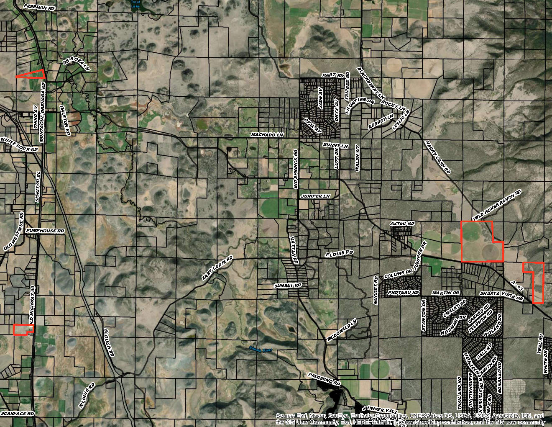
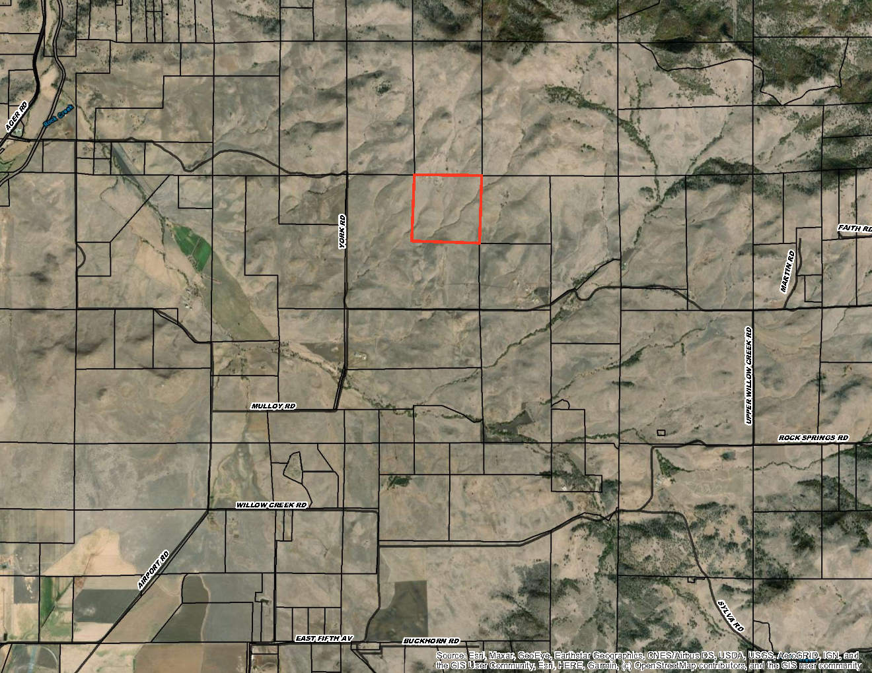
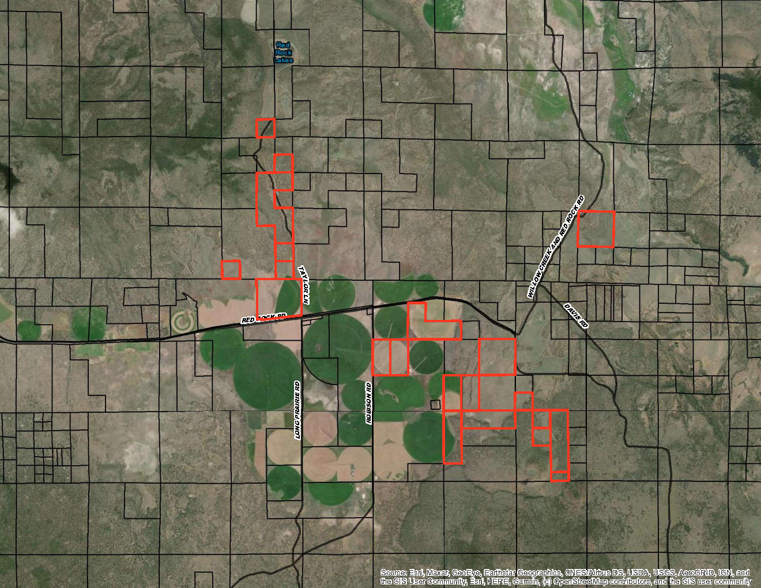
A notice of public hearing relating to the intention of issuing a notice of non-renewal was mailed on July 28, 2021 to all contract holders of the seven Williamson Act contracts referenced above, which notified them that their contracts are being recommended for non-renewal. It is anticipated that additional properties under Williamson Act contract will be brought forward to the Board for consideration of intent to issue a notice of non-renewal. Notice of the project was published and posted as required prior to the Board of Supervisors meeting and no public comment was received as of the preparation of this staff report.

Discussion
The Community Development Department has identified seven contracts for consideration of intent to issue a notice of non-renewal. Should the Board agree with staff’s recommendation and authorize staff to issue the notice of non-renewals, the Planning Department will file a Notice of Non-Renewal of Williamson Act Contract with the Assessor’s Office. The recordation will trigger property tax reassessment of the affected parcels and a nine-year period contract phase out will commence. Pursuant to Government Code Section 51246(a), development restrictions on non-renewed contracted parcels will remain in effect for the balance of the period remaining since the original execution or the last renewal of the contract.
Under Government Code Section 51245, if a local government desires not to renew a Williamson Act contract, it shall serve written notice of non-renewal of the contract upon the contracted party(ies) in advance of the annual renewal date of the contract. A city or county shall serve written notice of non-renewal at least 60 days prior to the renewal date, which would require Siskiyou County to serve the Notice of Non-Renewal by no later than November 1, 2021. It should be noted that under Government Code Section 51245, a local government is not required to have a reason or provide justification for issuing a notice of non-renewal, it is sufficient if the local government no longer “desires” to continue the contract. It is recommended that the Board of Supervisors simply state if they desire to continue with the Williamson Act contracts or not during deliberation of this item.
Agricultural Preserve Administrator Recommendation
On September 15, 2020, the Board of Supervisors amended the County’s Rules for the Establishment and Administration of Agricultural Preserves and Williamson Act Contracts, which included replacing the Agricultural Preserve Advisory Board with an Agricultural Preserve Administrator. The County’s Planning Director serves as the Agricultural Preserve Administrator, and part of the Administrator’s duties including providing recommendations relating to existing contracts including non-renewal of Williamson Act contracts.
The primary goal of the County’s Williamson Act properties is not just preservation of agricultural lands, but rather, assist property owners whose land is principally used for commercial agricultural production. The County’s participation in the Williamson Act provides property owners with incentives in the form of reduced property taxes in exchange for the continuation and success of commercial agricultural production. One of the County’s primary sources of general fund monies come in the form of property tax payments. These payments enable the County to provide for needed services to county residents and local government operations, many of which are mandated by the State. While it is important to protect and serve the County’s agricultural lands and producers, which is identified as a top priority within the County’s General Plan, the County also has the responsibility to enhance all stakeholders for the greater good of Siskiyou County. With that in mind, staff reviewed survey responses of contracted lands to ensure Williamson Act properties are meeting the intention of the County’s policies and is recommending the Board consider the intention of issuing a notice of non-renewal for seven Williamson Act contracts. It is Planning staff’s opinion that these contracts no longer meet the intention of the Williamson Act and/or our county policies due to either non-response, information provided on the survey response, and/or past/current activities.
However, staff’s opinion is in no way the basis for the County’s non-renewal and should not be considered as justification or reasoning for issuance of non-renewal should the Board adopt the recommended Resolution. Rather, it is recommended that the Board of Supervisors consider if it desires to renew the contracts or not under consideration of all services and local government functions Siskiyou provides to all county residents since the County no longer receives subvention payments to offset the losses cause by participating in the Williamson Act.

Environmental Review
Should any action result in the issuance of a notice of non-renewal of a Williamson Act contract, staff is recommending the Board determine the issuance of notice of non-renewal to be categorically exempt under the General Rule, Section 15061(b)(3) as this action would not cause a change in use and no change to the property’s underlining zoning would occur. As a reminder, Government Code Section 51246(a) requires development restrictions on non-renewed contracted parcels that will remain in effect for the balance of the period remaining since the original execution or the last renewal of the contract. This ensures that there will be no changes in uses or agricultural production for a minimum of a nine-year period, even if the property ownership were to change, further ensuring that the issuance of a notice of non-renewal would not result in any significant environmental impacts.

Recommended Motions

I move to adopt the Resolution hereby taking the following actions:
- The Board of Supervisors determine that the proposed issuance of a Notice of Non-Renewal of a Williamson Act contract is categorically exempt under the General Rule, Section 15061(b)(3) of the CEQA Guidelines, as this action would not cause a change in use and no change to the property’s underlining zoning would occur;
- Move to approve the attached Resolution directing staff to issue a notice of non-renewal for certain Williamson Act contracts; and

Authorize staff to process the Notice of Non-Renewals with any changes directed by the Board.

Attachments
- Draft Resolution, a Resolution of the County of Siskiyou, State of California, Directing Staff to Issue a Notice of Non-Renewal for Certain Contracts
  - Exhibit A-1 within Draft Resolution: List of Identified Contracts for Non-Renewal
  - Exhibit A-2 within Draft Resolution: Notice of Non-Renewal – Draft
  - Exhibit A-3 within Draft Resolution: Williamson Act Contracts recommended for Non-Renewal

